Regime Switching

Kun yu 16-704-389

Luoyi Zou 16-743-536

# Introdution

International equity returns are characterized by episodes of high volatility and unusually high correlations coinciding with bear markets. Recent studies have shed light on the relative higher correlation among international equity returns in bear markets than in normal times (for example, Erb, Harvey and Viskanta, 1994; Campbell, Koedijk and Kofman, 2002). This salient feature of asymmetric correlation is well captured by regime-switching (RS) model, which is developed by Ang and Bekaert (2002a). RS strategies need not be restricted to equity returns: There is strong evidence that regimes exist in U.S. and international short-term interest rates.

# Theoretical framework

The basic idea proposed by Hamilton (1989) unveiled structure of a regime-switching model, which permits data to be drawn from two or more regimes, namely possible distributions and assumes the transition from one regime to another. The driver of this transition is the realization of a discrete variable (the regime) following a Markov chain process. Furthermore, the transition will occur with a certain probability, which can either be constant or depend on other variables.

The empirical study on equity returns from the US, Germany and the UK conducted by Ang and Bekaert (2002a) has showed that the market return of a bear market regime with lower stock market returns and high volatile is correlated more highly than that of normal regime.

Furthermore, stong evidence of regimes in US and international short-term interest rate data has been found by Gray (1996), Bekaert, Hodrick and Marshall (2001) and Ang and Bekaert (2002b and c), among others, showing that regime switching behavior is not restricted to equity returns. To be more epecific, high persistence and low volatility at low levels shape constitute the salient features of short rates, while lower persistence and much higher volatility at higher levels. Again, RS models perfectly capture these features of the data. The evidence also supports the correlation between interest rate and equity regimes and suggests that this patern may be related to the stage of the business cycle.

# Implementation and empirical case study

Our application involves a universe of equity markets, including China, Japan, US, EMBI, Switzerland, North America, EU, UK, Pacific region. The sample period is from 1994 to 2017. In order to estimate P and Q, we use the MATLAB package for Markov regime switching models provided by Marcelo Perlin.

Table 1 contains the estimation results for the RS equity model. Panel B indicates that the first regime is a normal regime, where world excess returns are expected to yield 1.11 percent a month, with volatility 0.31 percent a month. The other regime is a volatile regime, with standard deviation 0.66 percent a month and with a lower but imprecisely estimated mean of 0.07 percent a month. The country betas in Panel C were estimated precisely and the emergent market has the largest beta.

From Figure 1a, we can see the cumulative returns of the ten markets over the sample period. Figure 1b shows the ex-ante and smoothed regime probabilities. From 2008 to 2012, we can see that there was a bear market with high-volatility, obviously which is resulted from the financial crisis of 2007-2008.

Figure 2 shows the different performance of these strategies. The RS strategy generally outperformed the world market from the beginning of the Great Financial Crisis, and generally outperformed the US and Swiss equity markets across the sampling period. The outperformance is particularly striking for the last nine years starting from 2009, where it outperformed the non-regime-dependent strategy particularly successfully, by more than 200%.

# Conclusion

The results from our implementation support the theory of this paper. It’s obvious that expected returns and volatility vary through time. Equity returns perform badly and were highly correlated during high-volatility period. So these changes between low- and high-volatility regimes can help to add value to portfolios. However, the results in RS strategy are highly linked to historical period, which would not be a perfect indicator of future success. Besides, the model ignores the transaction cost, which serves a main source of market friction. Additonally, this model is constrained within only one regime variable, which counter the reality world where regime variables should be test to yield a better results. Finally, the optimization in this strategy only focuses on first and second moments, but the preference of private or institution investor to positive skewness and dislike kurtosis should also be taken into account.

# Appendix

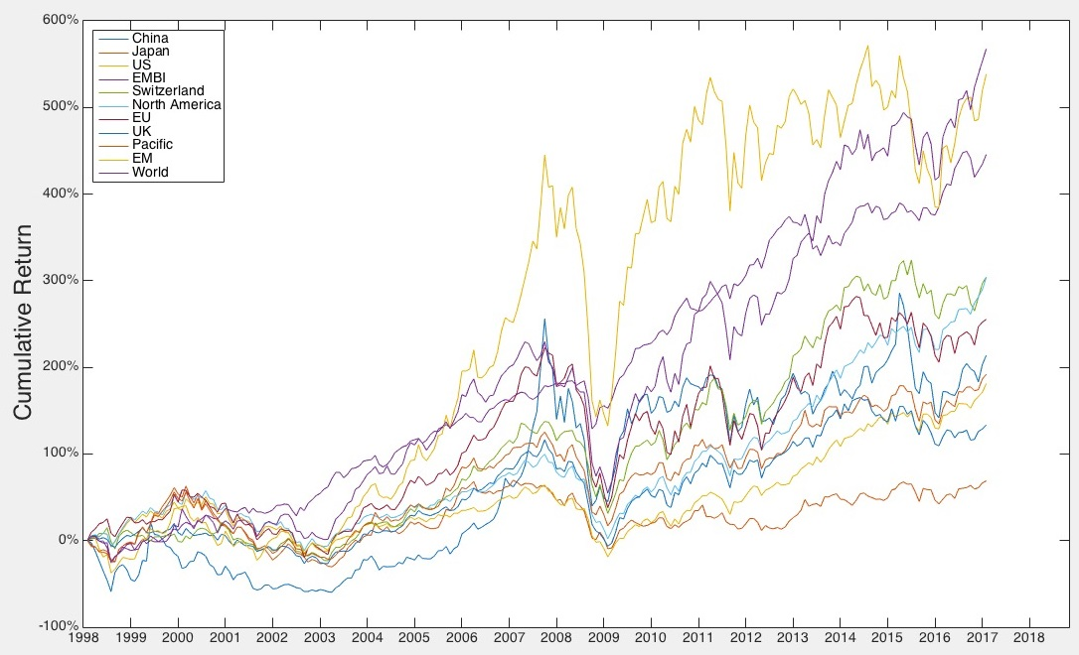Table 1: Empirical Part of the Sample

Figure 1a: Cumulated Returns

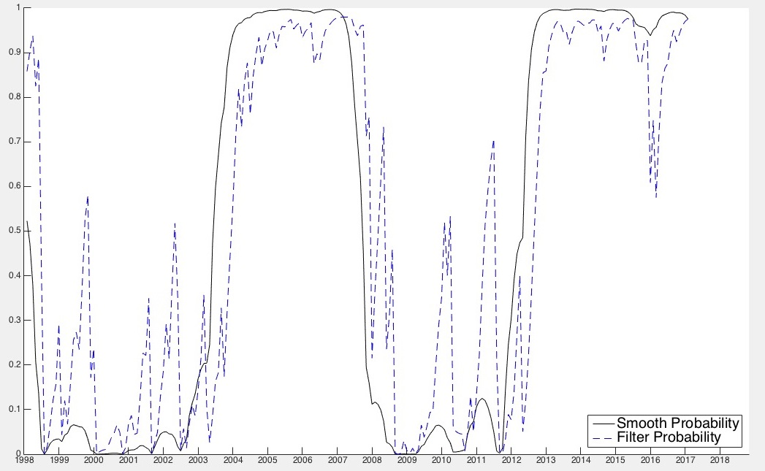   
Figure 1b: EX-Ante and Smoothed Probabilities

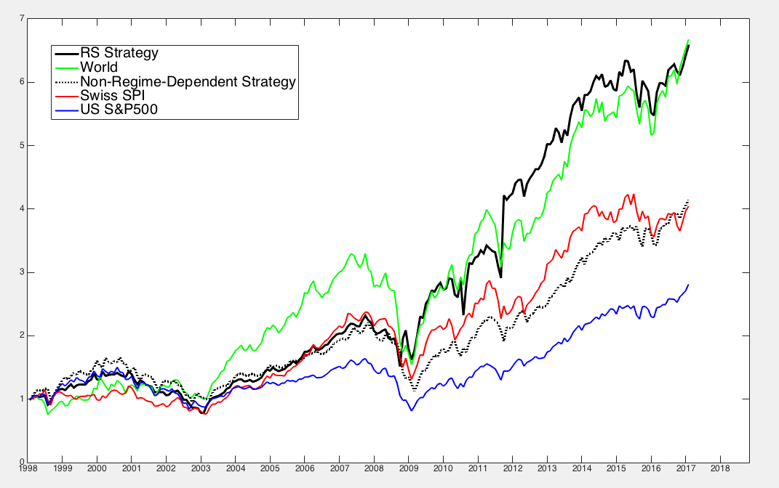

Figure 2: Out-of-Sample Wealth for Various Markets or Strategies, 1998-2017

# Reference

[1] Ang A, Bekaert G. How do regimes affect asset

allocation?[R]. National Bureau of Economic Research, 2003.

[2] Ang A, Bekaert G. International asset allocation with regime shifts[J]. Review of Financial studies, 2002, 15(4):1137-1187.

[3] Perlin M. MS_Regress-the MATLAB package for Markov regime switching models[J]. 2015.

[4] Jensen M C, Black F, Scholes M S. The capital

asset pricing model: Some empirical tests[J]. 1972.

[5] Gray S F. Modeling the conditional distribution

of interest rates as a regime-switching process[J]. Journal of Financial Economics, 1996, 42(1): 27-62.

[6] Markus Leippold, 2017, “Regime Switching”, Asset Management: Advanced Investments lecture notes